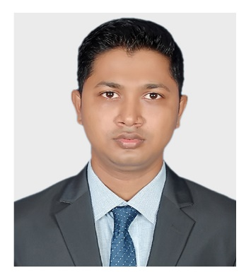**MD. MIZANUR RAHMAN**

**Mailing Address**

Address: 257-258 (5th floor), Rose Elegance,

Ibrahimpur Primary School Road, Ibrahimpur, Kafrul, Dhaka-1206.

Phone: 01680225343

Email: [themizan404@gmail.com](mailto:themizan404@gmail.com)

Github: [github.com/themizan404](https://github.com/themizan404)

LinkedIn: [linkedin.com/in/themizan404](https://www.linkedin.com/in/themizan404/)

**Career Objectives**

To work in an environment where there is an opportunity of self-assessment and self-improvement in both individual and group-based work that will ultimately lead to further development of the common people and Looking for a challenging opportunity to sharpen my skills and knowledge in a fast-paced organization and to grow as a lead.

**Education**

**Master of Social Science**

Subject : Economics

Institute : University of Dhaka

Result : Appeared

**Bachelor of Social Science**

Subject : Economics

Institute : University of Dhaka

Year of passing : 2018

CGPA : 2.99 out of 4.00

**Higher Secondary Certificate**

Institute : Adamjee Cantonment College

Year of passing : 2011

GPA : 4.60 out of 5.00

Group : Humanities

Board : Dhaka

**Secondary School Certificate**

Institute : Uttar Kafrul High School

Year of passing : 2009

GPA : 4.06 out of 5.00

Group : Humanities

Board : Dhaka

**Training**

1. IsDB IT Scholarship Project

Enterprise System Analysis & Design – JEE

**Skills**

Languages : Java, SQL, JavaScript, TypeScript, XML, CSS, HTML, UML

Frameworks : Spring, JSF, Angular 6, Swing, Hibernate

Mobile OS : Android

Libraries : JQuery, ReactJs, Bootstrap

Database : MySQL, Oracle, SQLite3, Firebase

Web Design : Html, CSS

VCS : Git, Github

Servers : Apache Tomcat, NodeJs, GlassFish

Concepts : Digital Marketing

**Projects**

1. Hospital Management & Information System

Technologies Used: Java, Spring, Tomcat, Hibernate, MySQL, Jquery, Bootstrap

Link: [github.com/themizan404/SpringProject](https://github.com/mizan404/SpringProject)

1. E-Voting Management System

Technologies Used: Java, Swing, MySQL

Link: [github.com/themizan404/All-Swing/tree/master/vote_management](https://github.com/themizan404/All-Swing/tree/master/vote_management)

**Personal Info**

Father’s Name : Md. Babar Ali

Mother’s Name : Sultana Parvin

Date of Birth : 16th Nov, 1994

Gender : Male

Religion : Islam

Nationality : Bangladeshi

Marital Status : Single

NID : 5550086796

Permanent Address : Pachani, Alaipur (9240), Rupsha, Khulna.

**Language Proficiency**

Bengali : Native speaker

English : Professional working efficiency

**References**

|  |  |
| --- | --- |
| 1. Moshaidul Islam  IsDB-BISEW, Consultant of IsDB-BISEW  01711071219  [moshaidul@gmail.com](mailto:moshaidul@gmail.com) | 2. Muhammad Maruf Hasan  IsDB-BISEW, Instructor of IsDB-BISEW  01825970006  [maruf.tcl@gmail.com](mailto:maruf.tcl@gmail.com) |



**Signature**